Education and careers

Professional certifications

CCST cybersecurity or Cisco Certified Support Technitian

Entry-lever certification  
 CompTIA Security+

Entry-level (important if you want to work for government)

EC Council Certified Ethical Hacker (CEH)

Knowledge of how to look for weaknesses and vulnerabilities in target systems using   
 the same knowledge and tools as malicious hackers

ISC2 Certified Information Systems Security Professional (CISSP)

Most recognized and popular security certification  
 need at least 5 years of relevant industry experience  
 Cisco Certified CyberOps Associate  
 validates skills required of associate-level cybersecurity analysts within security   
 operations centers

Security career pathways

[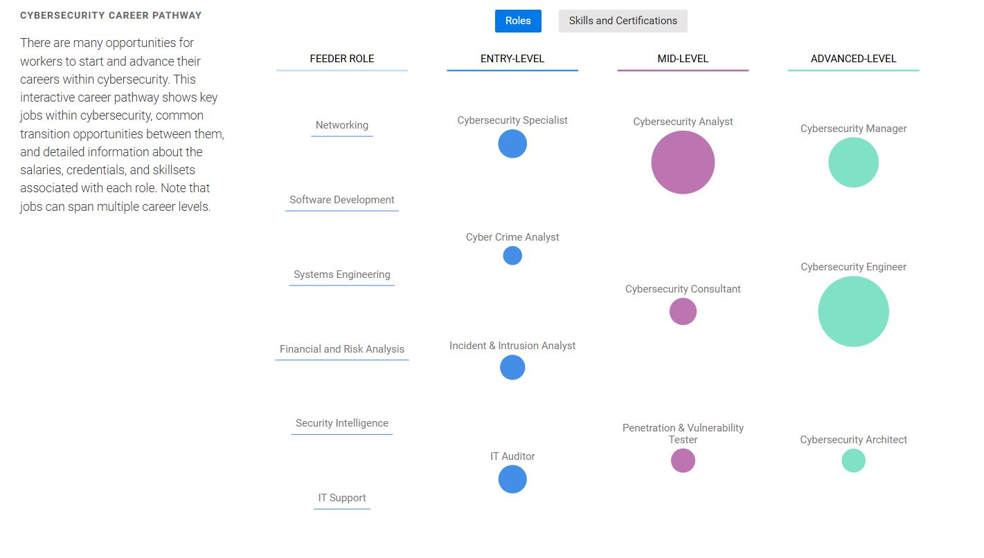](https://www.cyberseek.org/pathway.html)